**Day 5**

**C++ Constructors and Operators Overloading**

// C++ Default Constructor

/*

A constructor with no parameters is known as a default constructor.

C++ program to demonstrate the use of default constructor

*/

#include <iostream>

using namespace ***std***;

// declare a class

*class* Wall{

  private***:***

    double length;

  public***:***

    // create a constructor

*Wall*(){

      // initialize private variables

      length = 5.5;

      cout ***<<*** "Create a wall." ***<<*** endl;

      cout ***<<*** "Length = " ***<<*** length ***<<*** endl;

    }

};

int *main*(){

  // create an object

  Wall wall1;

  return 0;

}

/*

Create a wall.

Length = 5.5

--------------------------------

Process exited after 0.1771 seconds with return value 0

*/

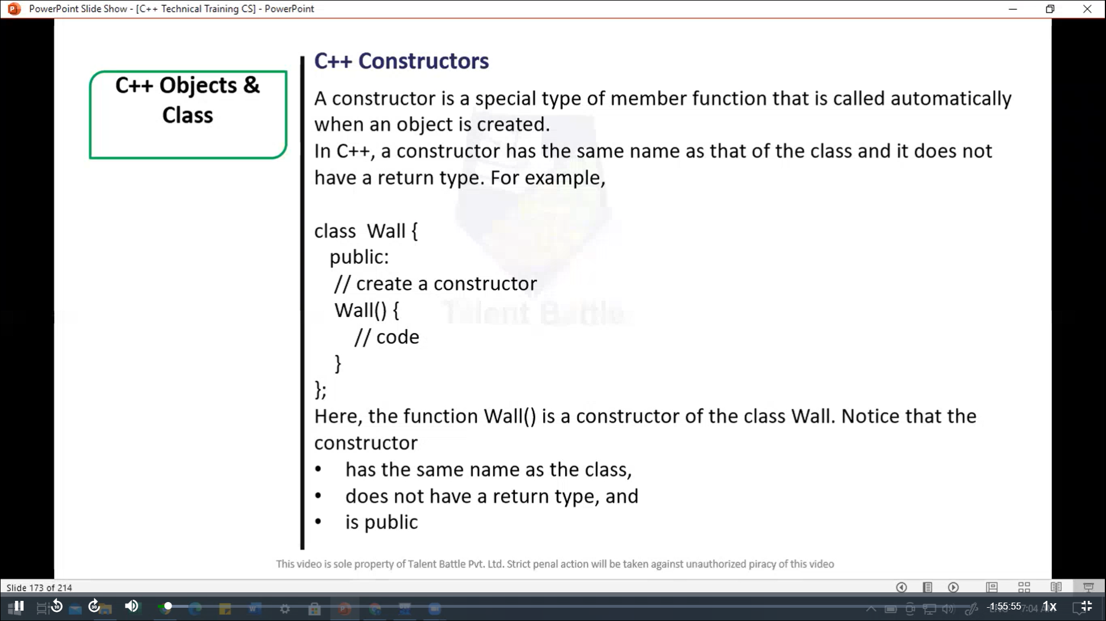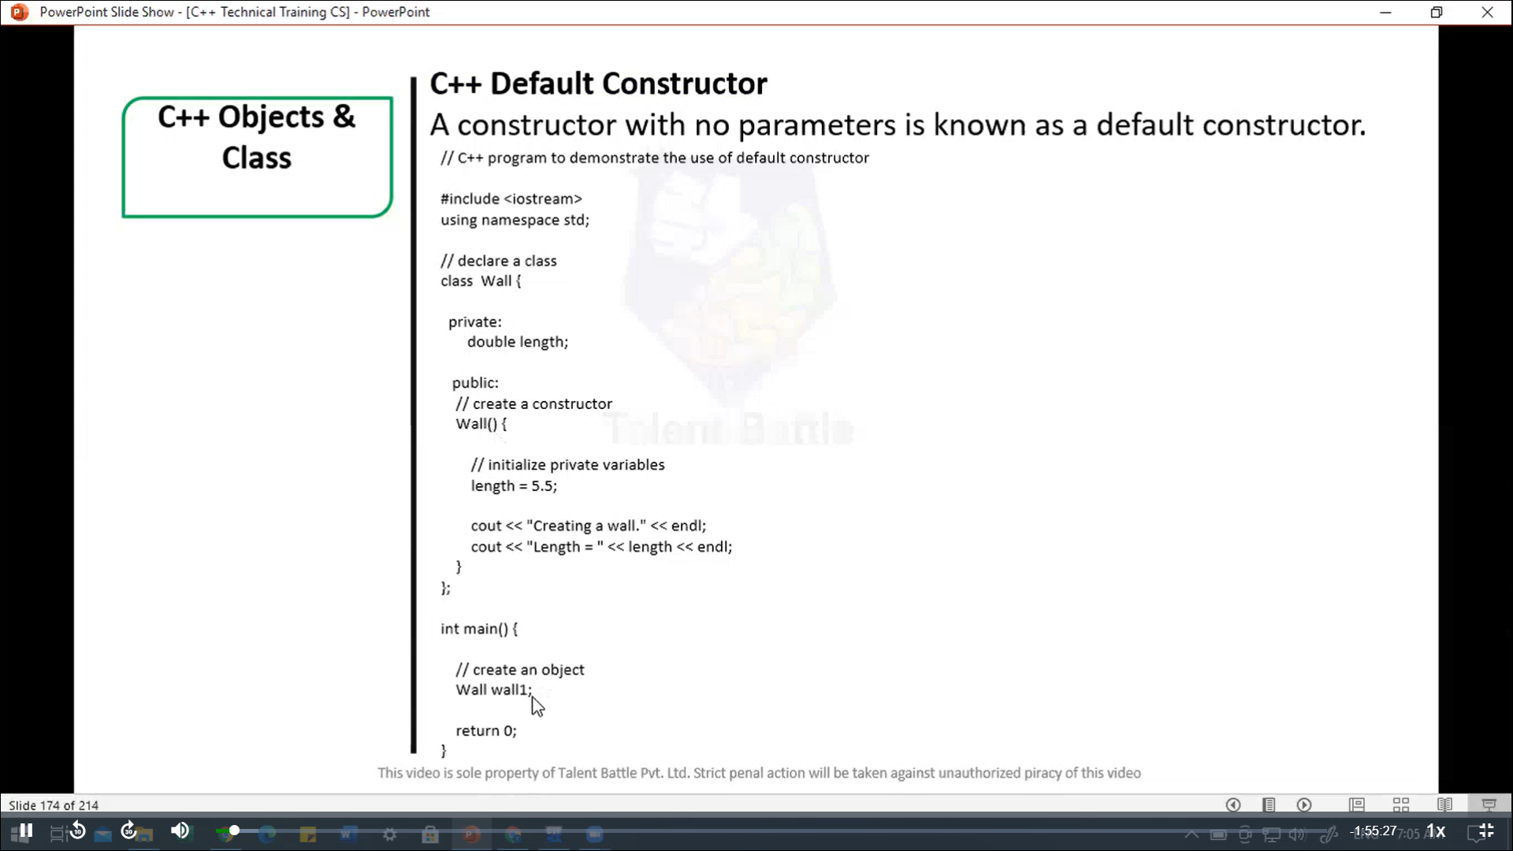

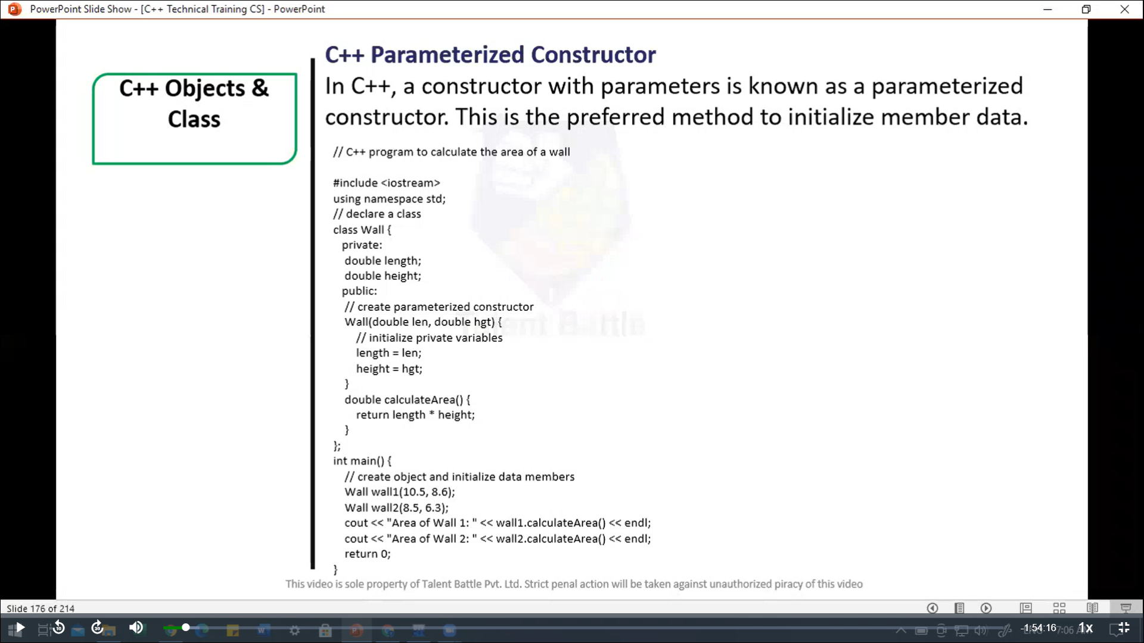

//==============================================

/*

C++ Parameterized Constructor

In C++, a constructor with parameters is known as a parameterized

constructor. This is the preferred method to initialize member data.

C++ Program to calculate the area of a wall

*/

#include <iostream>

using namespace ***std***;

// declare a class

*class* Wall{

  private***:***

    double length;

    double height;

  public***:***

    // creae parameterized constructor

*Wall*(double ***len,*** double ***hgt***){

      // initialize private variables

      length = ***len***;

      height = ***hgt***;

    }

    double *calculateArea*(){

      return length * height;

    }

};

int *main*(){

  // create object and initialize data members

  Wall wall1(10.5***,*** 8.6);

  Wall wall2(8.5***,*** 6.3);

  cout *<<* "Area of Wall1: " *<<* wall1***.****calculateArea*() *<<* *endl*;

  cout *<<* "Area of Wall2: " *<<* wall2***.****calculateArea*() *<<* *endl*;

  return 0;

}

/*

Area of Wall1: 90.3

Area of Wall2: 53.55

--------------------------------

Process exited after 0.1177 seconds with return value 0

Press any key to continue . . .

*/

//==================================================

// C++ Copy Constructor

// The copy constructor in C++ is used to copy data of one object to another

#include <iostream>

using namespace ***std***;

// declare a class

*class* Wall{

  private***:***

    double length;

    double height;

  public***:***

    // parameterized constructor

*Wall*(double ***len,*** double ***hgt***){

      // initialize private variables

      length = ***len***;

      height = ***hgt***;

    }

    // copy constructor with a wall object as parameter

*Wall*(Wall &***obj***){

      // initialize private variables

      length = ***obj.***length;

      height = ***obj.***height;

    }

    double *calculateArea*(){

      return length * height;

    }

};

int *main*(){

  // Create an object of Wall class

  Wall wall1(10.5***,*** 8.6);

  // print area of wall1

  cout *<<* "Area of Wall 1: " *<<* wall1***.****calculateArea*() *<<* *endl*;

  // Copy contents of wall1 to another object wall2

  Wall wall2 = wall1;

  // print area of wall2

  cout *<<* "Area of Wall 2: " *<<* wall2***.****calculateArea*() *<<* *endl*;

  return 0;

}

/*

Area of Wall 1: 90.3

Area of Wall 2: 90.3

--------------------------------

Process exited after 0.1467 seconds with return value 0

Press any key to continue . . .

*/

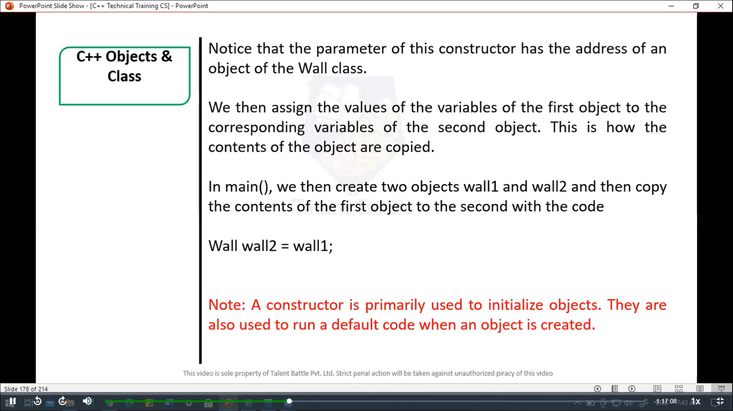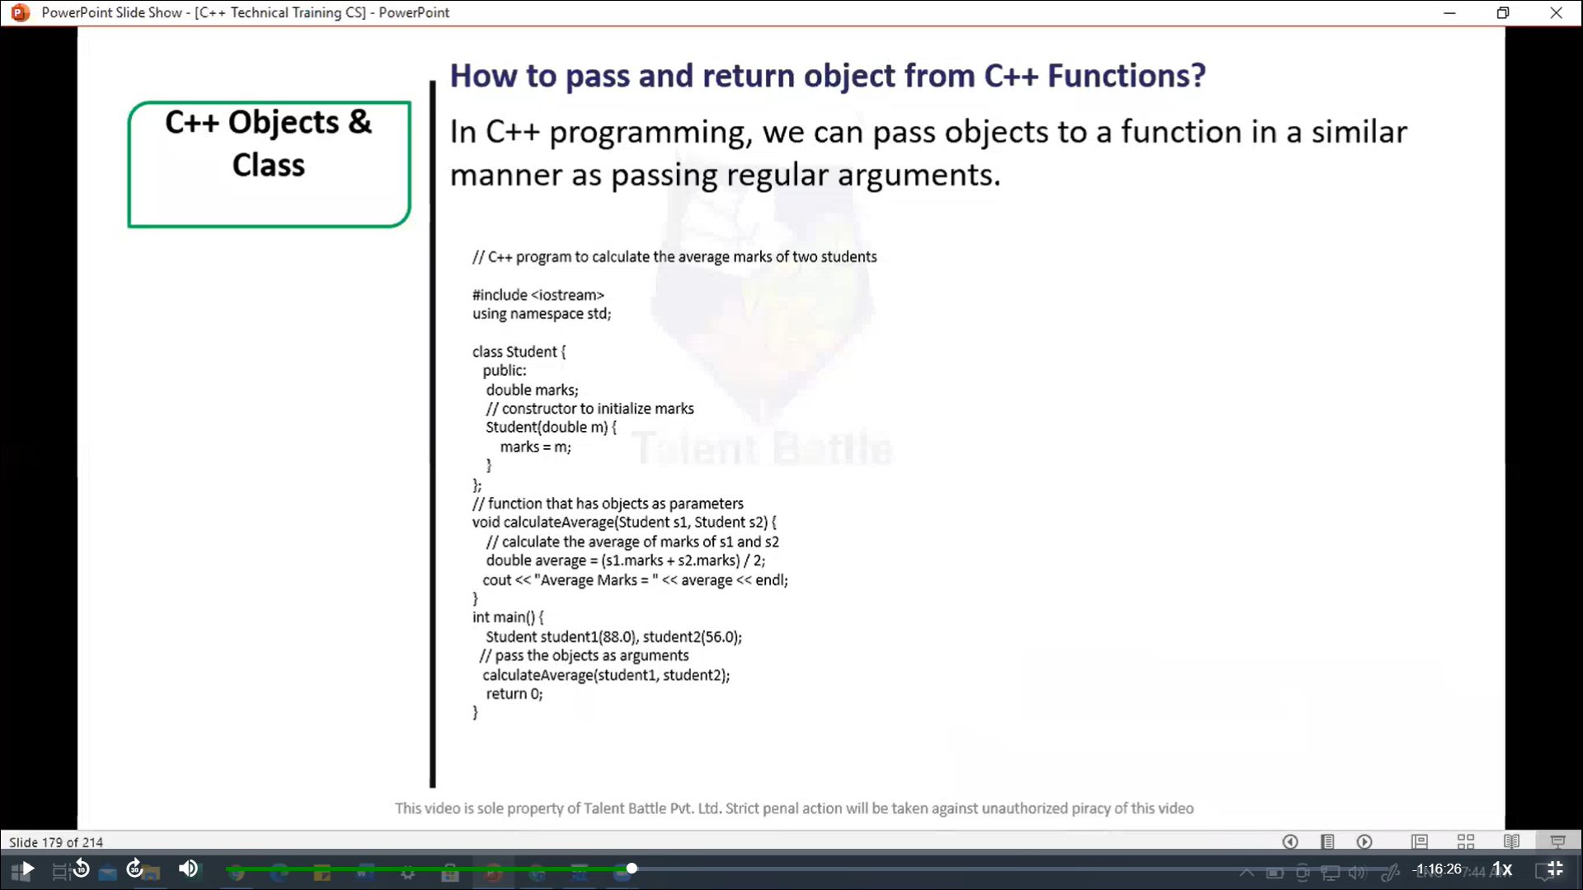

//=======================================================

/*

How to pass and return object from C++ functions?

In C++ programming, we can pass objects to a function in a

similar manner as passing  regular arguments.

*/

// C++ program to calculate the average marks of two students

#include<iostream>

using  namespace ***std***;

*class* Student{

  public***:***

    double marks;

    // constructor to initialize marks

*Student*(double ***m***){

      marks = ***m***;

    }

};

// function that has object as parameters

void *calculateAverage*(Student ***s1,*** Student ***s2***){

  // calculate the average of marks of s1 and s2

  double average = (***s1.***marks + ***s2.***marks) / 2;

  cout *<<* "Average Marks = " *<<* average *<<* *endl*;

}

int *main*(){

  Student student1(88.0)***,*** student2(56.0);

  // pass the objects as arguments

*calculateAverage*(student1***,*** student2);

  return 0;

}

/*

Average Marks = 72

--------------------------------

Process exited after 0.1455 seconds with return value 0

Press any key to continue . . .

*/